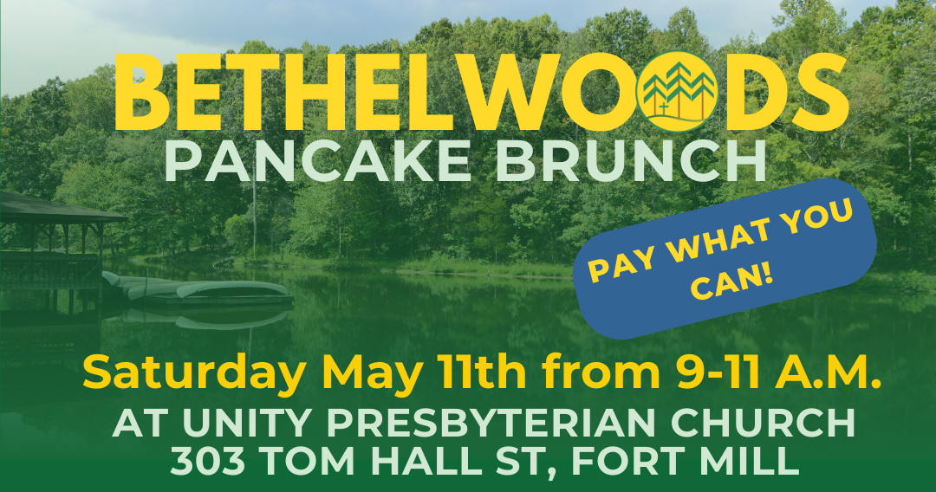

We can all recall amazing camp moments from our pasts, and the experiences made year-round in Bethelwoods Camp and Conference Center programs change the lives of children, teens, and adults. For 59 years, Bethelwoods Camp and Conference Center has been a significant fixture in South Carolina. Hosting thousands of people each year from throughout South Carolina and far beyond, Bethelwoods Camp and Conference Center helps each person grow in mind, body, and spirit while experiencing God’s love. From outdoor adventure camps for kids to spiritual retreats for adults, Bethelwoods Camp and Conference Center has become a premier destination, welcoming events, outdoor exploration, and individual growth. Attendance continues to rise year after year!
Every year, Bethelwoods Camp and Conference Center achieves our goal of offering a place where people can grow in mind, body, and spirit by experiencing God’s love with the help of our many supporters. Bethelwoods Camp and Conference Center is excited about its spring fundraising pancake brunch coming up on Saturday, May 11, 2024, at Unity Presbyterian Church located at 303 Tom Hall Street, Fort Mill, SC 29715. We hope that you would consider being a sponsor! At this brunch, we will serve pancakes, bacon, fresh fruit, coffee, and juice.
Bethelwoods is a place set apart for campers of all ages and stages of life. Last year, Bethelwoods Camp and Conference Center hosted 492 kids for week-long summer camp programs, 326 campers at weeklong camps hosted by outside organizations, 1822 guests for day visits, 1124 guests for adult retreats, and 662 children and youth at retreats throughout the year. This is just a sample of the many people who experience and love Bethelwoods Camp and Conference Center annually!
We hope you will consider serving as a 2024 pancake brunch sponsor! Your generosity will help Bethelwoods Camp and Conference Center continue to serve God’s children in God’s creation. As a sponsor, you could receive recognition at the event, in our newsletter, on a social media post, and each week at camper pick-up.
We warmly invite you to consider becoming a part of our loyal donor family. As each attendee leaves Bethelwoods, our prayer is that they were spiritually nourished, refreshed, or revived, having experienced God uniquely and personally while with us. Your donations demonstrate your belief in the value of this prayer, allowing us to continue to serve the guests, making lifelong memories at Bethelwoods Camp and Conference Center.
To become a sponsor, please return the enclosed sponsorship agreement by May 1, 2024. Thank you in advance for considering this opportunity to help all of us at Bethelwoods Camp and Conference Center. Please contact us with any questions.
Thank you for making a difference,
Rev. Mia Levetan, Board Vice President
Bethelwoods Camp and Conference Center

